

**Project Report:**



MOVIE BOOKING SYSTEM

**Group Members:**

Muhammad Daniyal Ashfaq

Muhammad Mahad Hasan

**INTRODUCTION**

Watching movies is one of the entertainment medium these days. People need to surf various website to watch trailers of the movies. They need to browse through different websites to get the movie review.

Once they find a movie suited to their liking, they need to go to theatres to book ticket. For this they need to stand in queues to buy tickets.

To ease all these problems we have proposed a solution as Online Movie Ticket booking.

**ACKNOWLEDGE**

We would like to express our sincere gratitude to all those who contributed to the successful completion of this project, the "Movie Booking System." First and foremost, we extend our deepest appreciation to Miss Aqsa Noor whose guidance, support, and invaluable insights were instrumental throughout the development process. Your mentorship not only enhanced the technical aspects but also fostered our overall growth as a programmer. We are also thankful to the Aptech’s faculty for providing an enriching learning environment and resources essential for executing this project effectively.

This project has been a significant learning experience, and we are grateful for the opportunity to have worked on it



**REQUIRMENTS**

***Visitor or Registered user:***

* He/she needs to first register on this web portal.
* He /she can enjoy watching trailer for movie.
* He/she can book movie ticket by selecting show time and show date.
* He/she can opt to our three classes and can select any one of the three classes.
* We have special concessions for kids (aged between 3 to 12 years).
* He/ she can read movie details and reviews along with their ratings at our web portal.

***Admin***

* Admin is the main backbone for this portal.
* Admin is responsible for adding and editing a movie theater.
* Admin will add, edit and delete movies for each movie theaters.
* Admin will be responsible for adding, editing and deleting show time for movies.
* Admin can also view the number of users that are registered to the web portal.

**Online Movie Booking system features**

* Login and Registration for users.
* View show time just by selecting your preferred date.
* Movie Reviews and ratings.
* Movie trailers.
* Payment Gateway needs to be added to this project.(Optional)
* Admin dashboard.
* Add, delete and edit movie theaters.
* Add, delete and edit movies.
* Add, delete and edit shows and their rates for each classes.

**MOVIEBOOKINGSYSTEM**



This website focuses on helping moviebooking.

Home Page:



**ADMIN -PANEL**

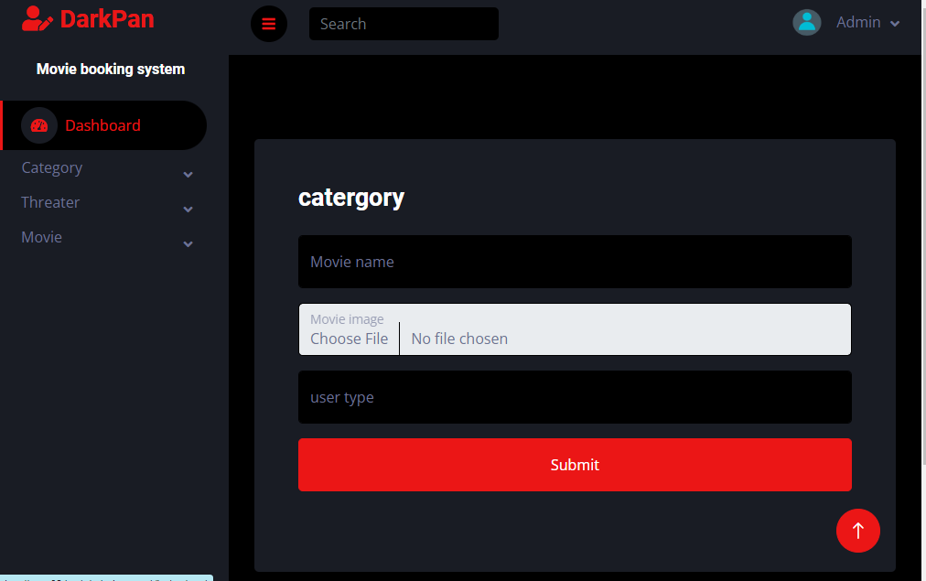

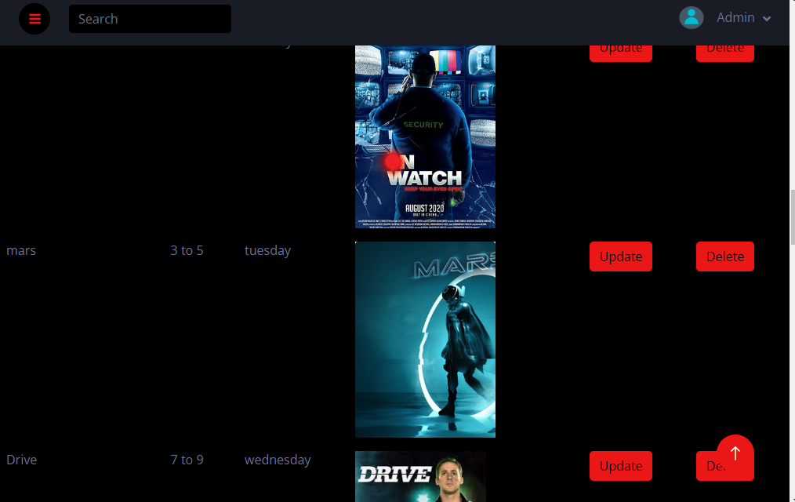

**User Manual:**

* **Registration:**

To access the features of the system, users need to register first. Navigate to the registration page and provide necessary details like name, email, password, etc.

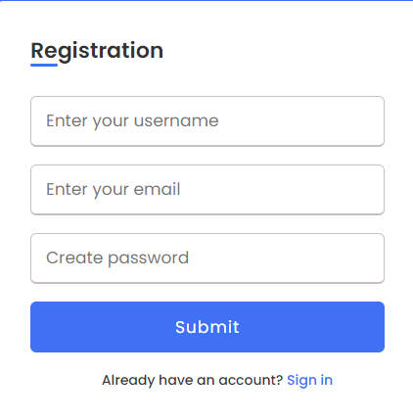

* **Login:**

Once registered, users can log in using their email and password. After logging in, users gain access to the full functionality of the system.

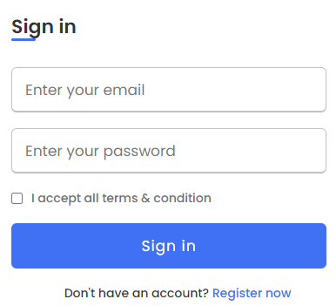

* **Browsing Movies:**

Upon logging in, users are directed to the home page where they can see a list of available movies.

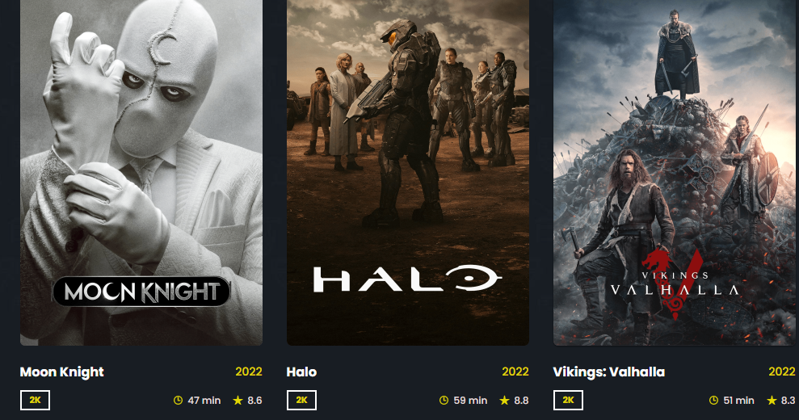

* **Watching Trailers:**

By clicking on a movie's thumbnail or title, users can access its details page. Trailers for the selected movie are available for viewing on this page, allowing users to get a glimpse of the film before booking tickets.

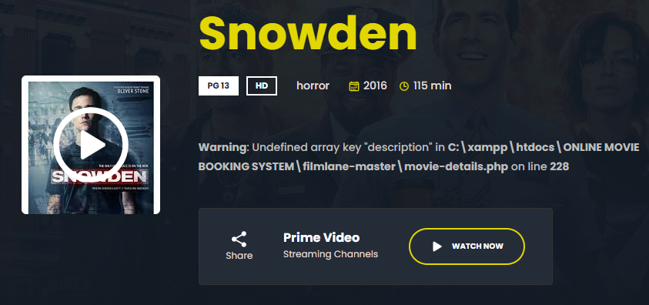

* **Selecting Showtime:**

On the movie details page, users can see available showtimes for the selected movie. Users can choose a preferred date and time for the show they wish to attend.

* **Choosing Seats:**

After selecting a showtime, users are directed to the seat selection page. Users can see the layout of the theater and choose their desired seats from the available options

Source code:

Home:

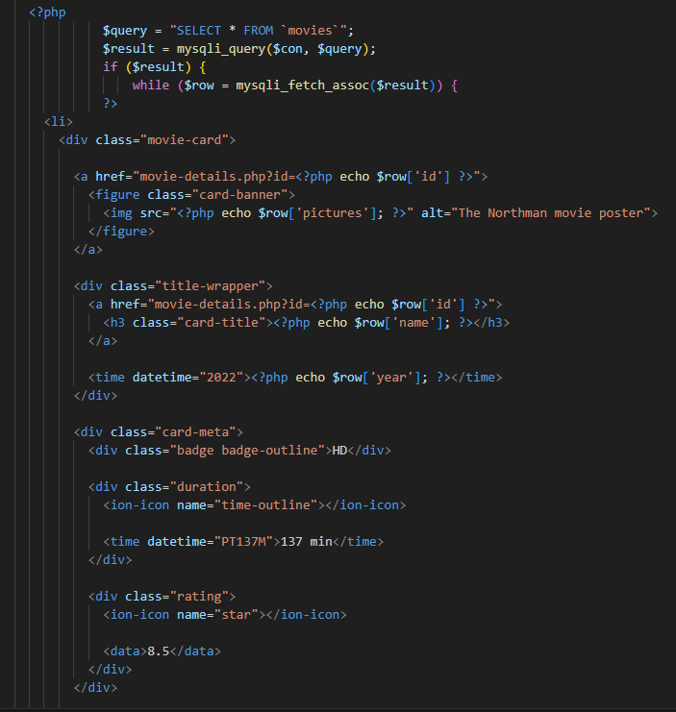

For adding movie: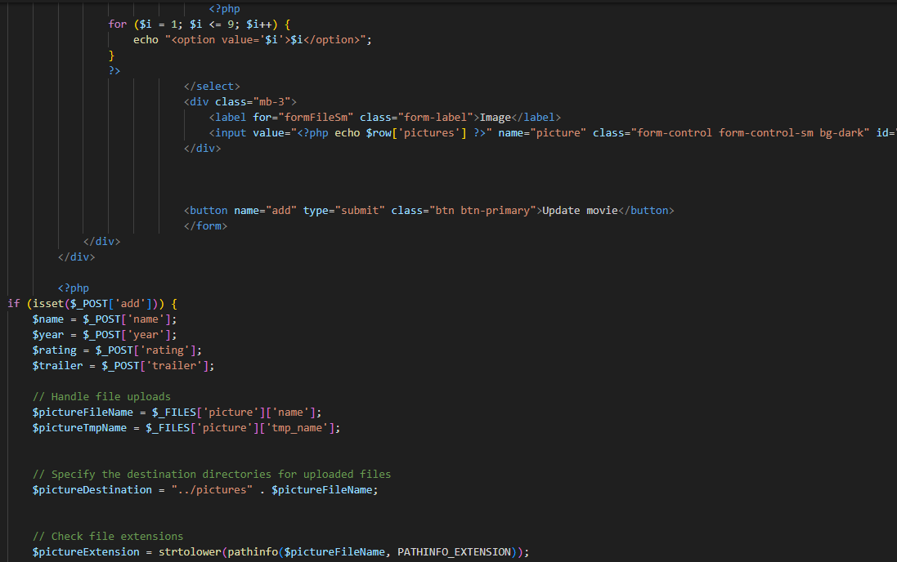

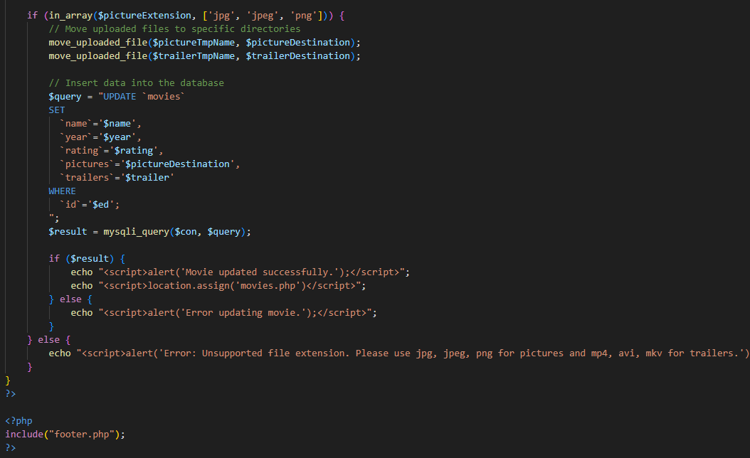

For updating theatre:

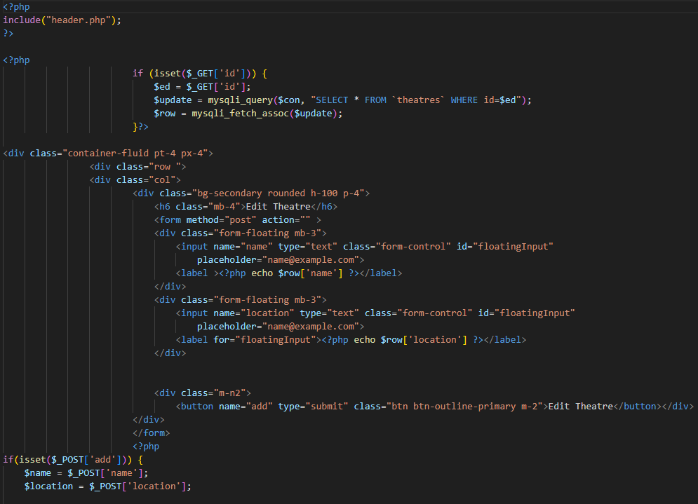

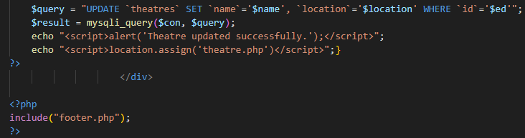

For booking:

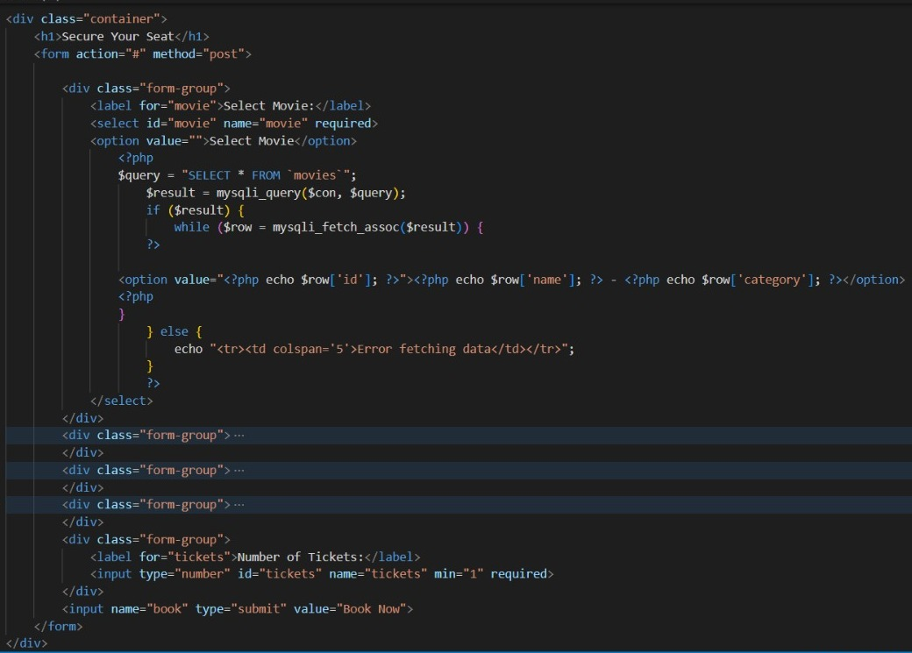

**DATA BASE:**

